Schematics review – David - 25.11.2021
- USB output : adding voltage divider to have 2.5v on the D+ and D-
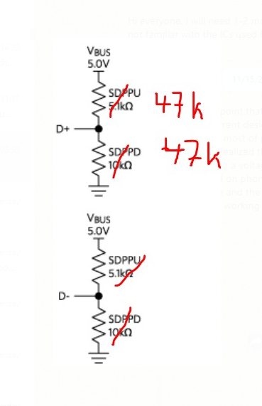 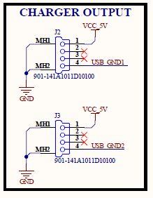
- The MOSFET 4 should be connected to one of the 6 pins of the AtMega that has a PWM output to regulate the white light intensity. PB0 does not allow that.
Proposition : Connect the white LED MOSFET 4 to PD6, As LED2 is connected to PD6, it can be connected to PB3 instead. This led would actually also give an indication during programming since PB3/D11 is also the MOSI for the ISP programming.

- The pin RX should also be connected to PD3 to be able to raise interruption on INT1
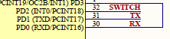

- A0 should be connected to VBAT, if we want to measure battery voltage with uC without using the voltage divider and 1.1v internal reference (measure with A1)
- This part should be renamed “External communication” and it’s not used for programming
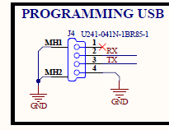
- (optional) There is a battery under-voltage protection with the BD48K25 that block the battery discharge at 2.5V. I saw in the datasheet that there also other chip for any value between 2.5 and 6V. If available, it would actually be better to put BD48K30 or BD48K29 and block the discharge at 3.0 or 2.9 V. Discharging the battery in less deep level will extend it’s lifetime.

Question/remarks :
- There is a battery under-voltage protection with the BD48K25 (It would actually be better to put BD48K29 and block the discharge at 2.9 V), for but what is in place for short-circuit protection for the battery ?
- Why is there one mosfet for each USB output ? Is there any benefit (eg power rating) ? In term of usage, the two USB output will be always activated/desactivated at the same time.
- The TPS2115 is a powerful chip and adapted in this design, but couldn’t we find a more cost effective solution ? (maybe to be changed in a later stage, at the same time as reducing uC cost)
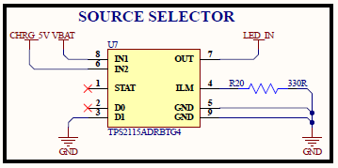

PCB Layout design v1 :
- PCB size and user interface (connectors, switch,etc) identical to the PCB sent :
